Cole Te

**Website Development**

Website Requirements:

* Website must contain at least one navigation bar to assist the user in navigating different sections of my website.
* Website must have a homepage and multiple more pages to contain different sections of my topic.
* Logos, texts, and images must be responsive so that it scales with the screen size of the user’s device. Moreover, they must be readable and are formatted in appealing fashion.
* Must have multiple pages to contain different sections for different topics regarding Bristol
* Navigation for the whole website must be easy to use and simple. It must respond well to any inputs from the user as well.
* Visitors can access a platform where they can contact official support when visiting Bristol.

Target Audience:

Young audiences that are interested in visiting Bristol or the Bristol community, whether they live here or not.

Website purpose:

* To showcase ‘Banksy’s’ exploits with his street arts.
* To inform people of Banksy’s story or history while in Bristol.
* Allow people to see the locations of Banksy’s arts.
* Allow people to contact official support when visiting Bristol

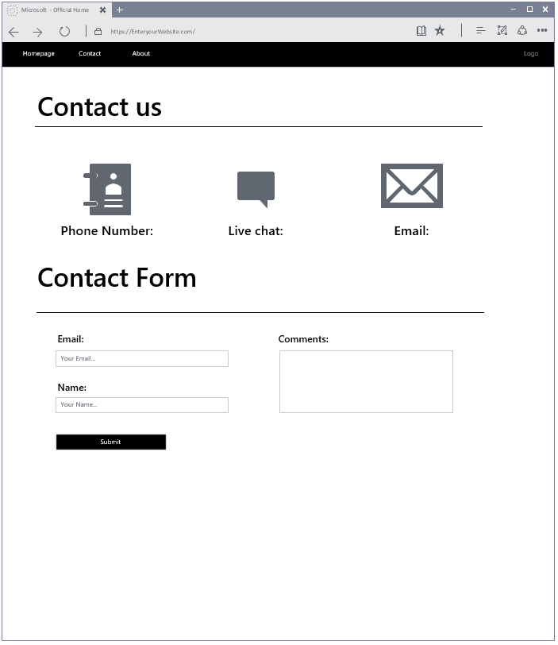**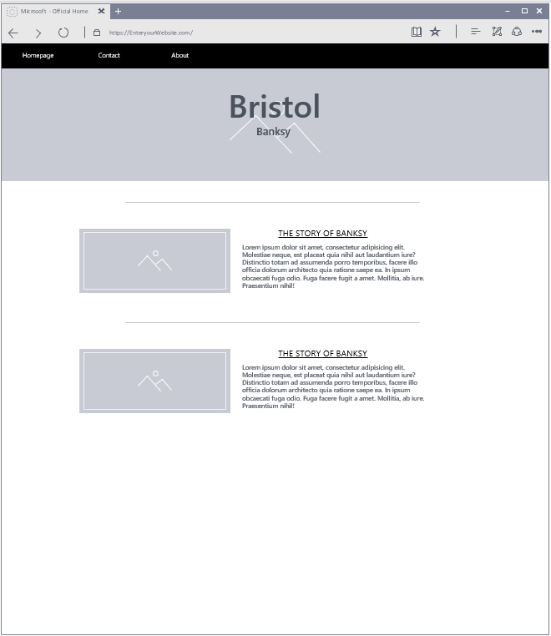Design Prototypes:**

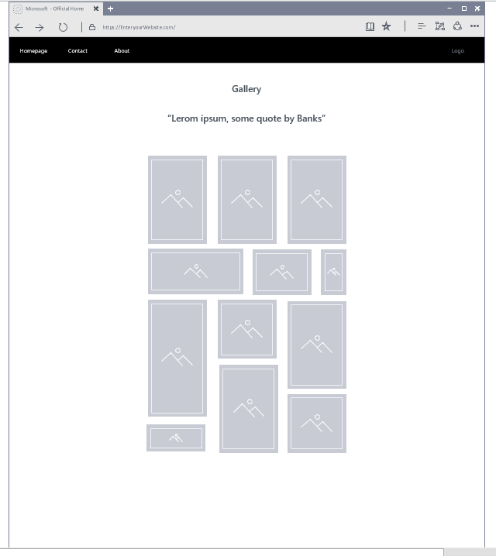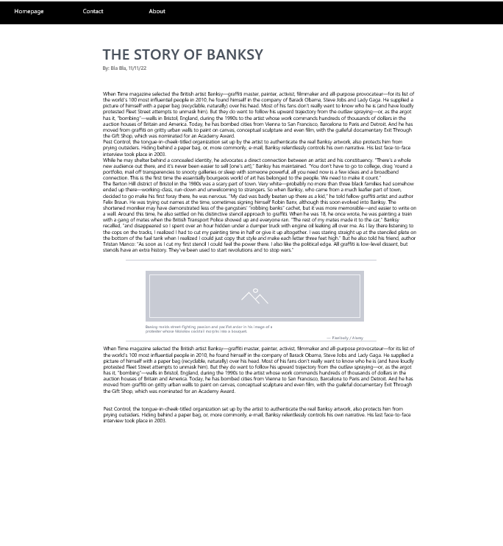

**Alternative designs (mobile):**

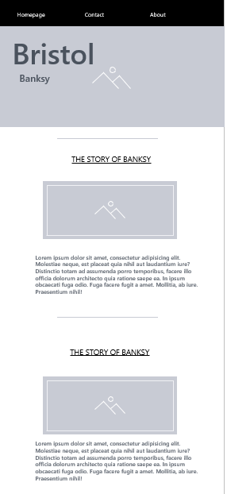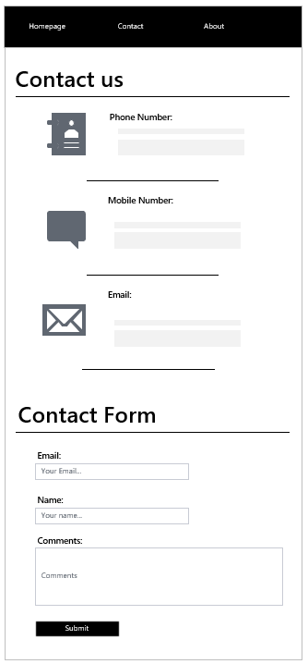

I wanted my website to look simple and appealing to allow for easier navigation and less hassle experience for the user. Because of this, I opted for a simple layout with easy-to-read fonts and styles, several text separators, and a very simple navbar on the top. With this, I would be able to clearly present my thoughts regarding Bristol aspects. Furthermore, with how all the containers are arranged, it would be very easy to make them responsive (not much is changed with the layout) with different screen sizes and allows me to have less risk of errors during my work. This would let me be able to finish faster and have more time allocated to work with the actual content.

I also made some alternative designs designed for mobile whilst still able to have the same simple layout that I wanted to make. As you can see, I just used text separators to clearly organise different ideas of my topics.

Other pages will have the same layout as presented here, both for desktop and mobile.

**Moodboard:**

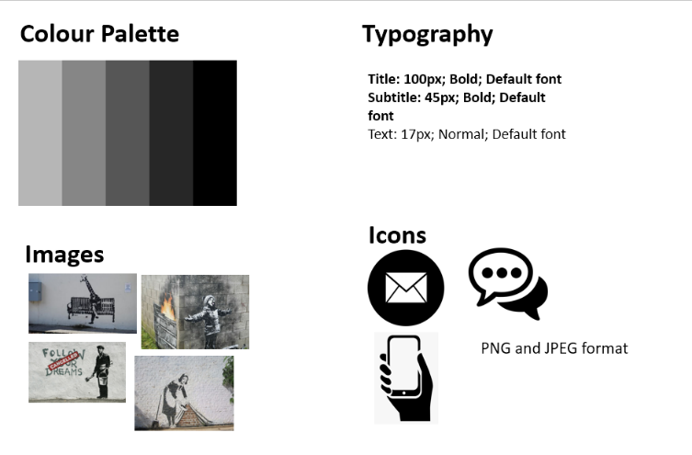

As I have clarified earlier, I wanted my website to look just simple. Therefore, I decided to use black, white, and grey to complement with my layout. Furthermore, they are easy to work with as I do not have much to think about which colour is appropriate in where.

The images I would have to show in the gallery page will only be Banksy’s arts, which all complement well with my colour palette as most of his arts have tinges of black and white colours.

Overall, together with my layout and the Moodboard I have made, I would have a simple-looking website and an article-like layout because of its simple and clear organisation.

**Search Engine Optimisation (SEO)**

Search Engine Optimisation or SEO is used to link certain keywords with websites that have a similar topic or purpose. For example, if someone searches for “online shopping”, well-known websites such as Amazon, eBay, or anything similar would have a higher change of showing up in the front (if they are optimised) whereas websites that does not have to do anything with “online shopping” would not show up.

**Keywords:**

* Bristol
* Bristol community/ies
* Banksy
* Street arts
* Graffiti

**Assets**

|  |  |  |  |  |
| --- | --- | --- | --- | --- |
| **Asset Name** | **Format** | **Asset description** | **Original/Ready-made** | **Alt tag** |
| Pic 11 | JPG | Giraffe sitting on a bench | From Banksy | Giraffe sitting |
| Pic 10 | JPG | Man cleaning graffiti | From Banksy | Man cleaning |
| Pic 9 | JPG | Woman cleaning | From Banksy | Maid |
| Pic 8 | JPG | Boy shouting/war cry | From Banksy | Boy screaming |
| Pic 7 | JPEG | Boy feeling snow | From Banksy | Boy in snow |
| Pic 6 | JPG | Swan beside the river | From Banksy | Swan |
| Pic 5 | JPG | Girl patting-down a soldier | From Banksy | Little girl |
| Pic 4 | JPG | Little girl holding a balloon | From Banksy | Girl with balloon |
| Pic 3 | JPG | Astronaut carrying bags | From Banksy | Astronaut |
| Pic 2 | JPG | Man painting | From Banksy | Man painting |
| Pic 1 | JPEG | Man attacking people with trend arrow | From Banksy | Man attacking |
| Main image | JPEG | Man on horse | From Banksy | Horse |
| Logo 1 | JPG | Mobile phone | Internet | Logo 1 |
| Logo 2 | JPG | Bubble chat | Internet | Logo 2 |
| Logo 3 | PNG | Email logo | Internet | Logo 3 |

**Testing plan**

**Functionality testing:**

|  |  |  |  |  |  |  |
| --- | --- | --- | --- | --- | --- | --- |
| **Test Number** | **Purpose of test** | **Page** | **Input data** | **Expected result** | **Actual result** | **Fix/improvements** |
|  |  |  |  |  |  |  |
|  |  |  |  |  |  |  |

**Usability testing / feedback:**

|  |  |  |  |
| --- | --- | --- | --- |
| **Test number** | **Purpose of test** | **Page** | **Comments** |
|  |  |  |  |
|  |  |  |  |

Both testing details will be added later on after the actual website have been made.

**Design feedbacks**

Feedback # 1

|  |  |  |  |  |  |
| --- | --- | --- | --- | --- | --- |
| **Number** | **Question** | **Disagree/No** | **Neutral/No opinion** | **Agree/Yes** | **Comments/improvements** |
| 1 | Were the design simple and appealing? |  |  | Yes | The homepage’s layout could be improved, such as emphasising more on the titles; “Story of Banksy” and “Gallery”. |
| 2 | Was the whole layout for all pages consistent? |  | Neutral |  | None |
| 3 | Do you think the Moodboard suits well with the layout design? |  |  | Yes | None |
| 4 | Do you think the navbar placement and/or design is appropriate? |  |  | Yes | None |

Feedback # 2

|  |  |  |  |  |  |
| --- | --- | --- | --- | --- | --- |
| **Number** | **Question** | **Disagree/No** | **Neutral/No opinion** | **Agree/Yes** | **Comments/improvements** |
| 1 | Were the design simple and appealing? |  |  | Yes |  |
| 2 | Was the whole layout for all pages consistent? |  |  | Yes |  |
| 3 | Do you think the Moodboard suits well with the layout design? |  | Neutral |  | More details can be added, it feels empty. |
| 4 | Do you think the navbar placement and/or design is appropriate? |  |  | Yes |  |

I don’t think not much questions can be asked considering that the Visio designs were empty and is not very accurate. However, both feedbacks still allowed me to have insight on the user’s thoughts and ideas. Therefore, I slightly redesigned the layout for the homepage:

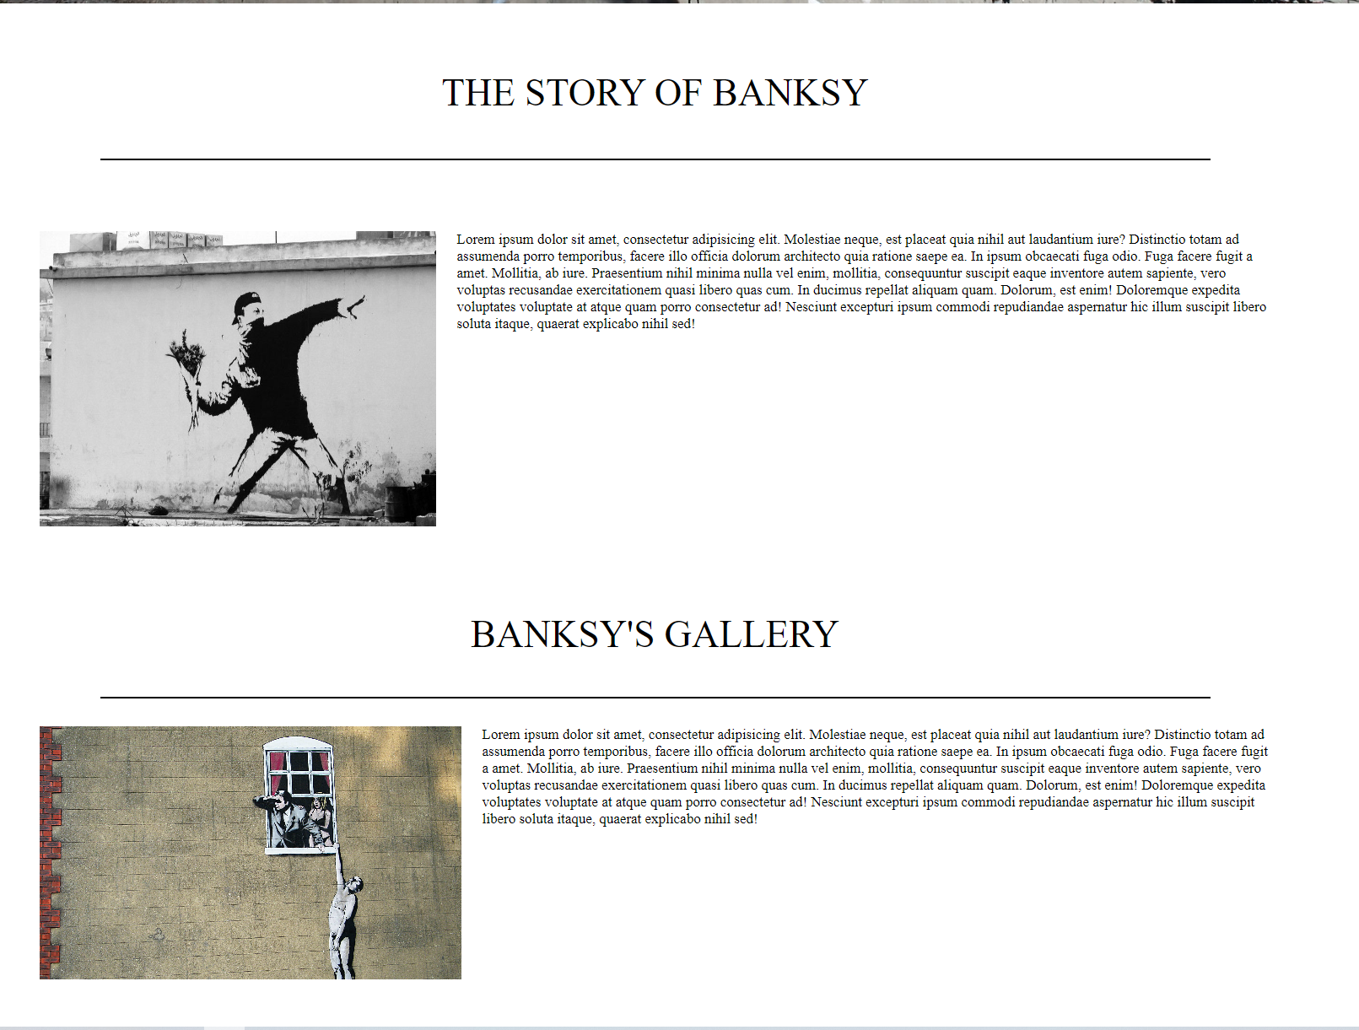

As seen in the image, I made both titles look emphasised more. And to add life to the homepage, I made a new container for both sections to act in a way when the user’s mouse hovers over them, it would expand itself, which would hint the user that it is a clickable link, unlike the previous design where the title doesn’t seem to hint it.

Although feedback#2 made a good point regarding details and the website feeling empty, I would try to improve once as the website content and responsiveness have been fixed and added. I think this way would be more appropriate to actually determine whether or not the details in the designs were lacking.

Through these two changes, the website seems to be more interactive with the user, and although still quite empty, its approach to simplicity allows it to be straightforward, giving the user an easier time in navigating, experiencing, and especially learning from the content of my website. This idea appeals to the purpose of my website, which is to educate and assist people who wishes to visit or lives in Bristol.

**Website Development**

**Screenshots:**

Homepage:

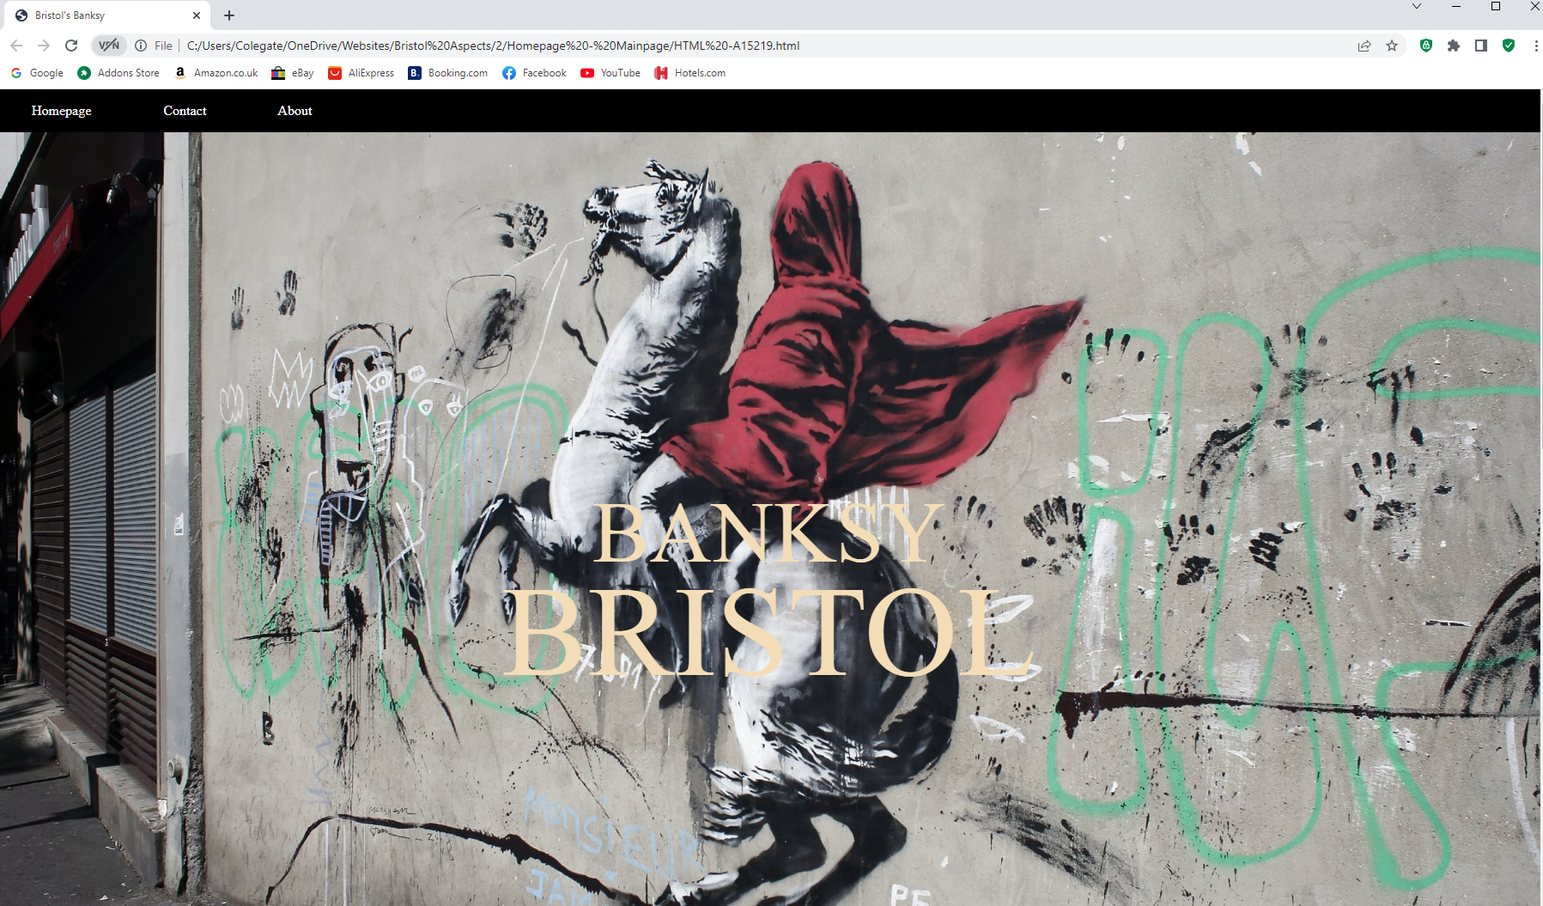

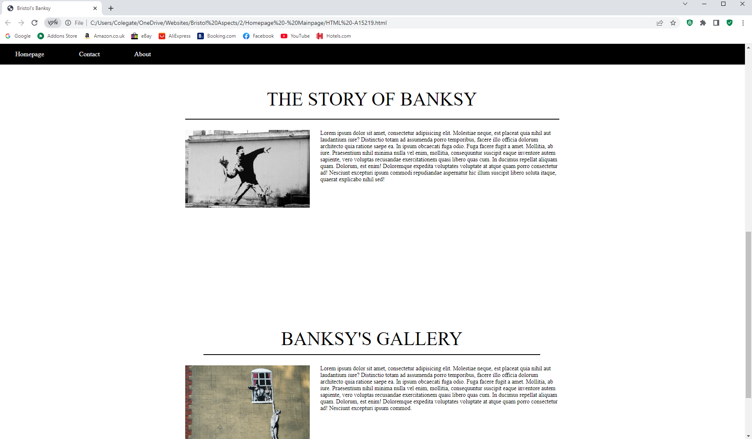

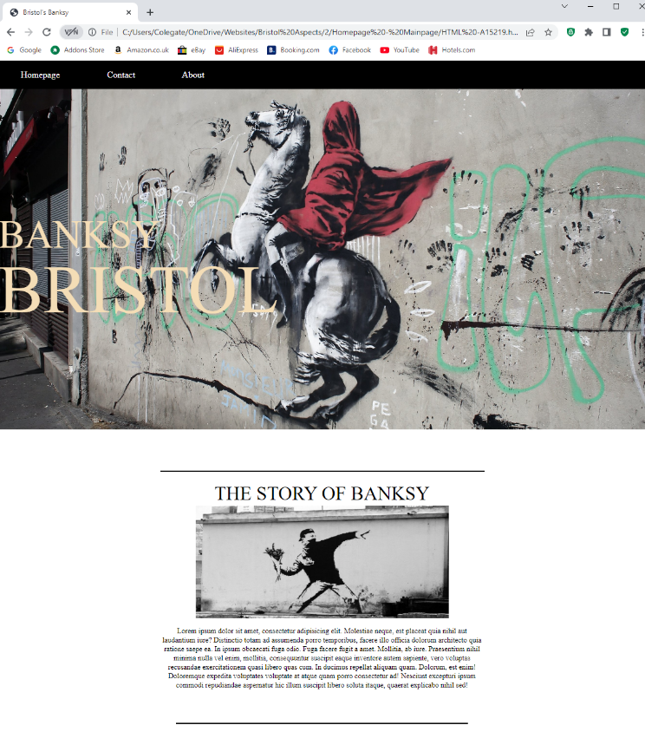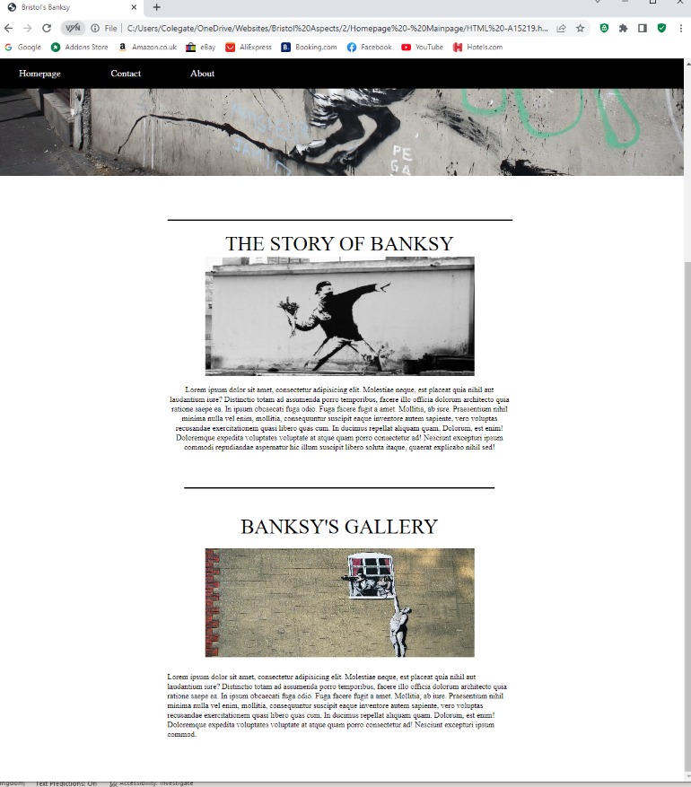Homepage (Portrait/Mobile version):

Contact Page:

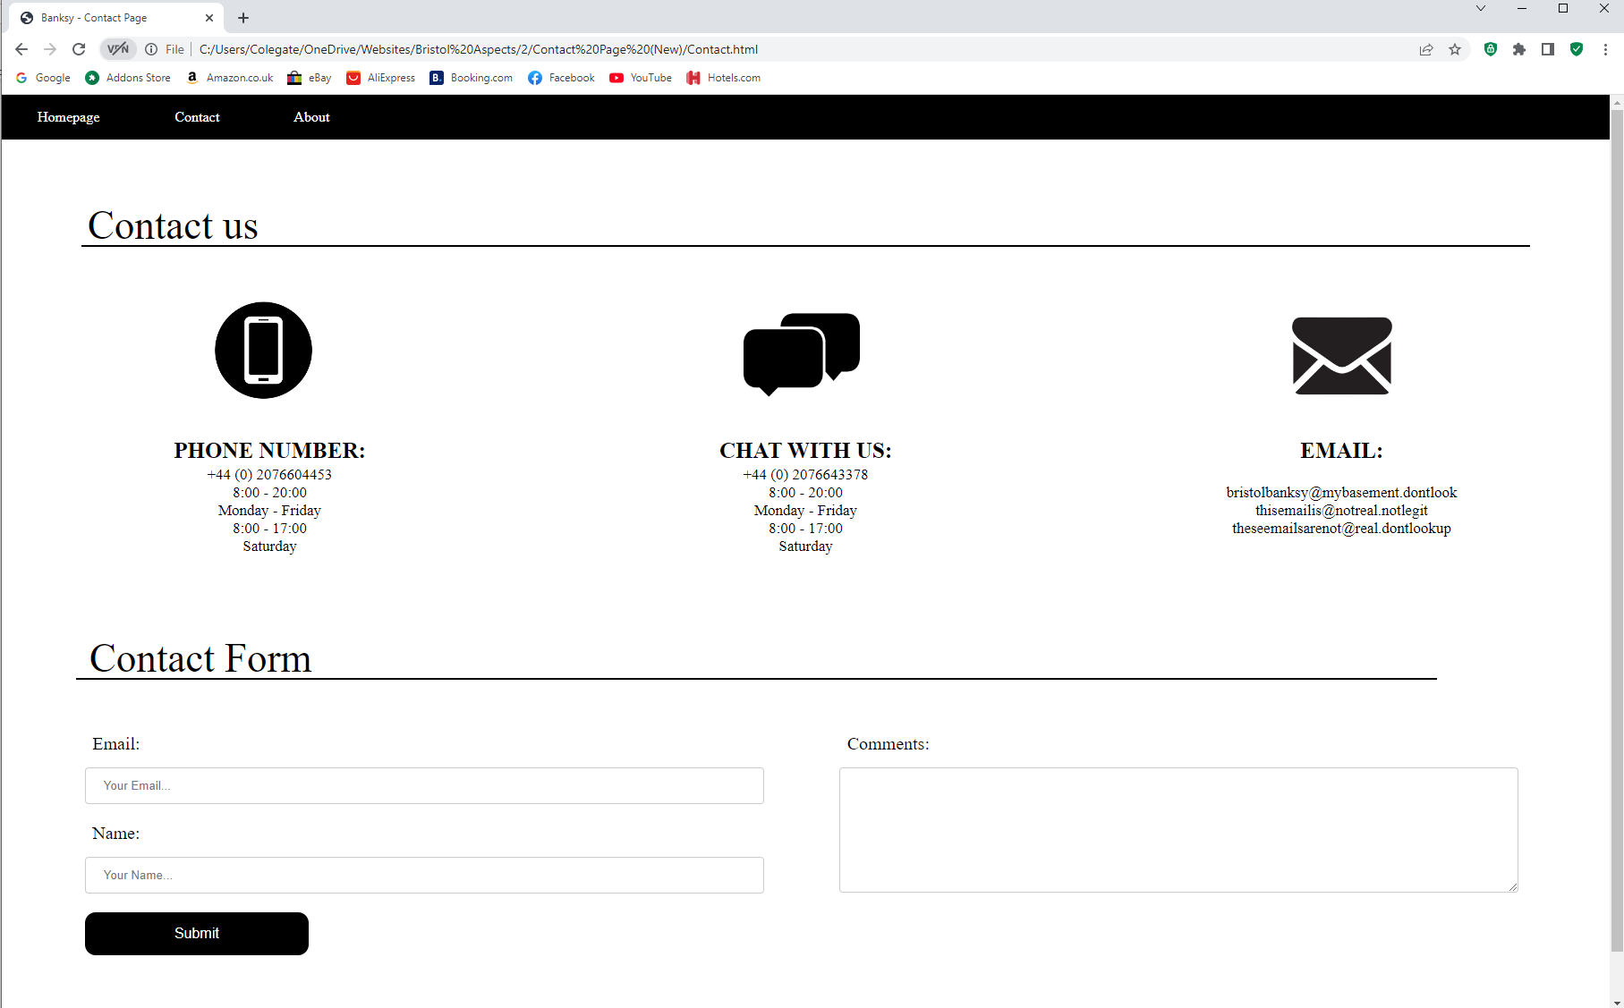

Contact Page (Portrait/Mobile version):

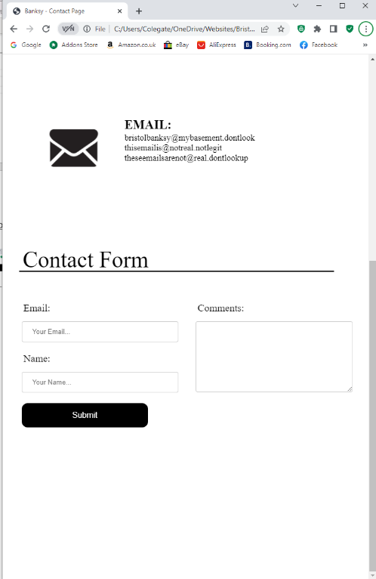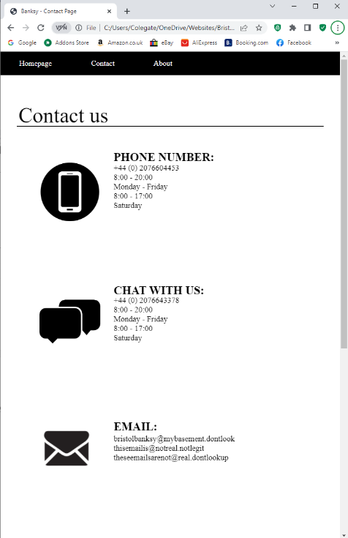

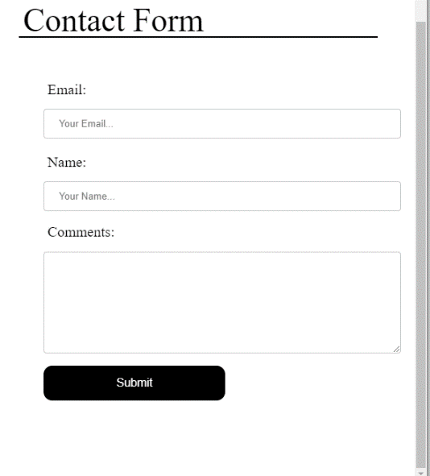

Banksy’s Story Page: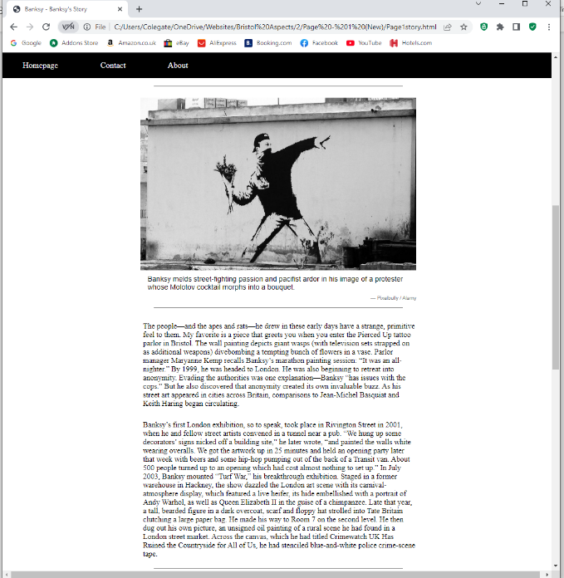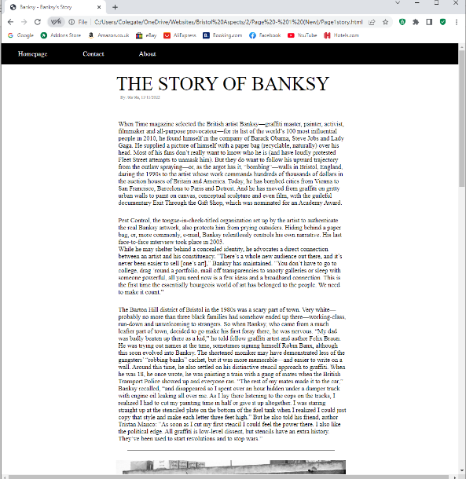

Banksy’s Gallery:

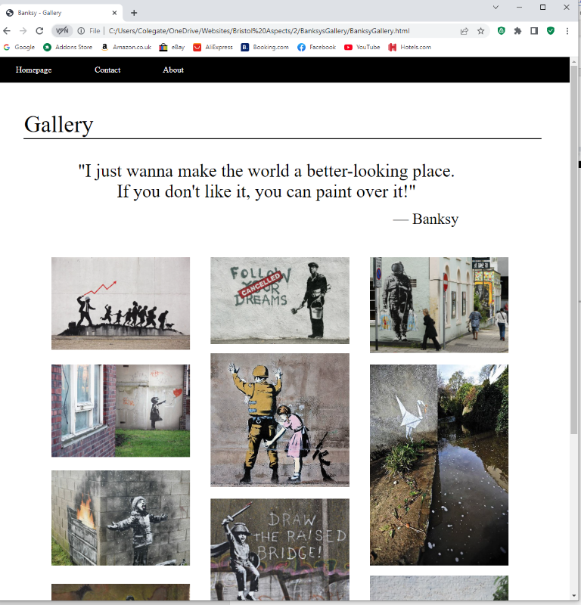

**HTML:**

Homepage:

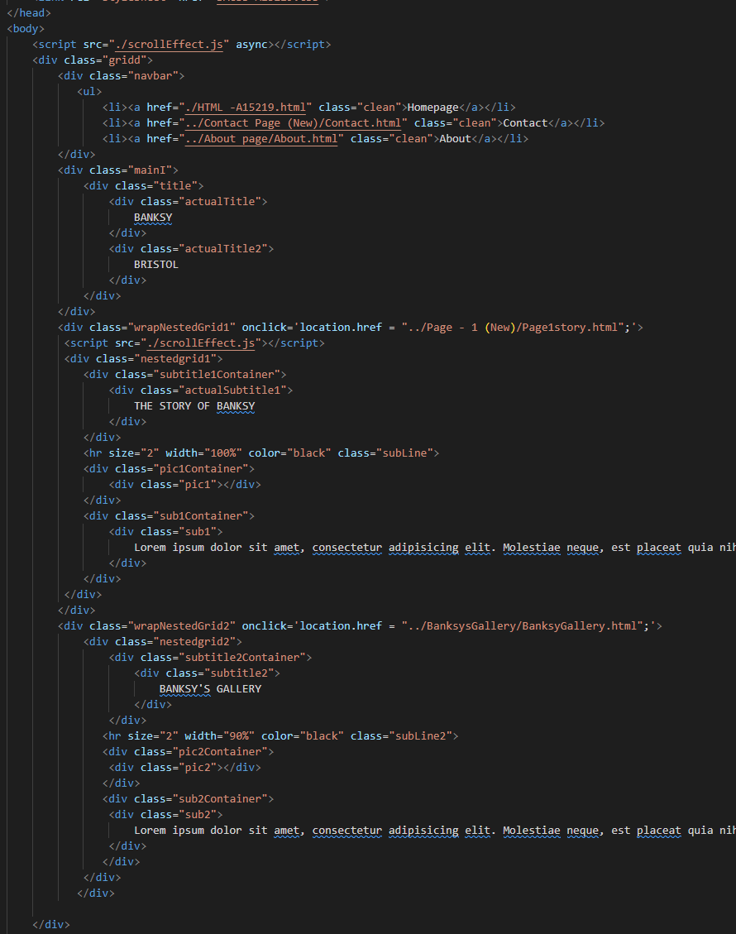

Contact Page:

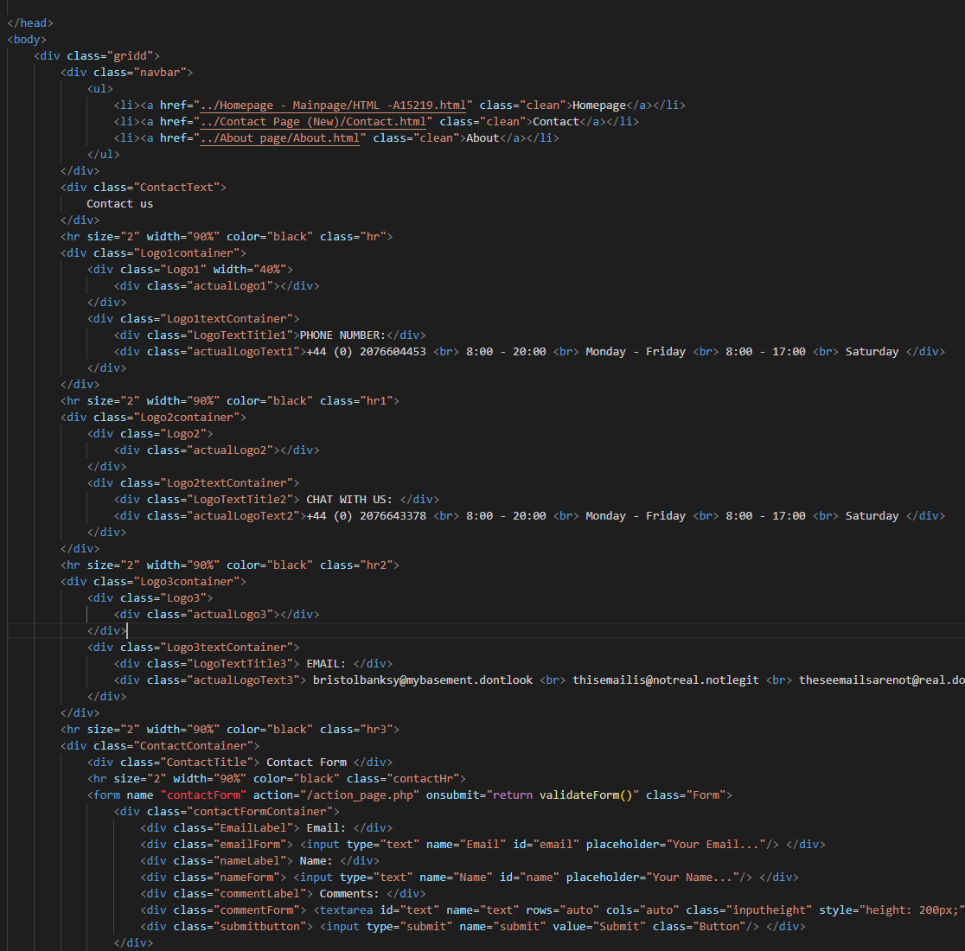

Banksy’s Gallery

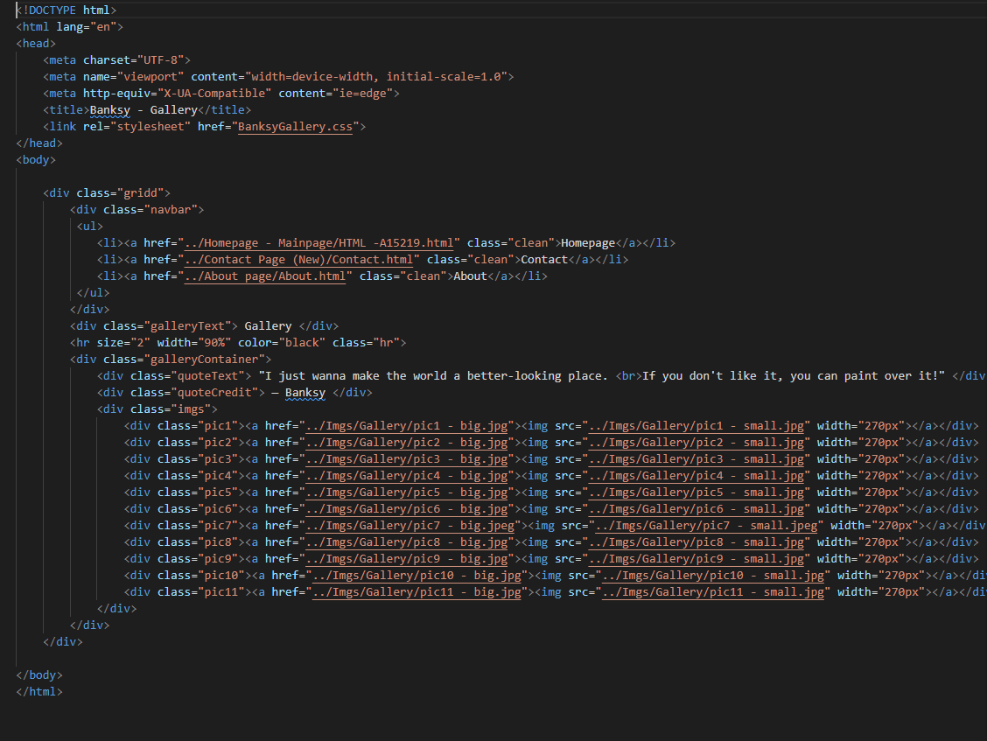

Banksy’s Story:

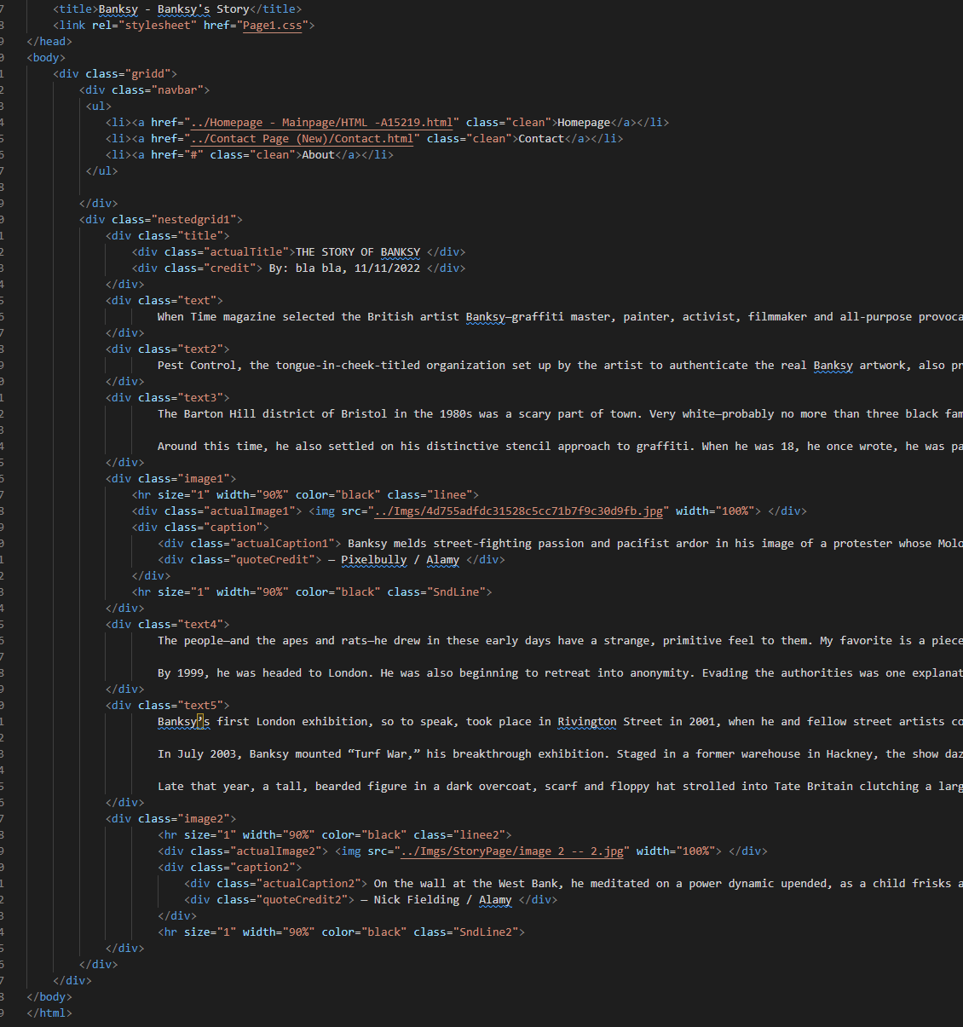

**CSS:** *(Only Containers)*

Homepage:

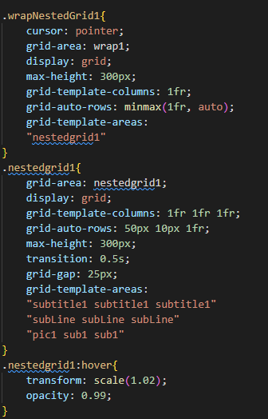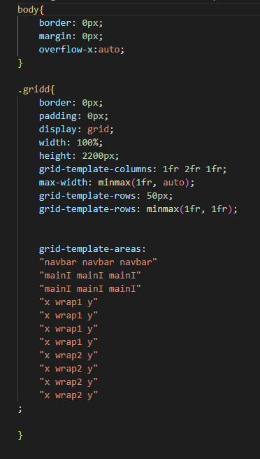

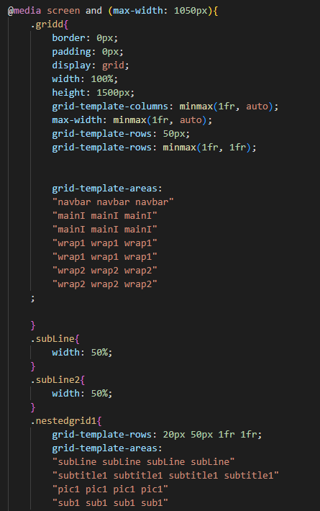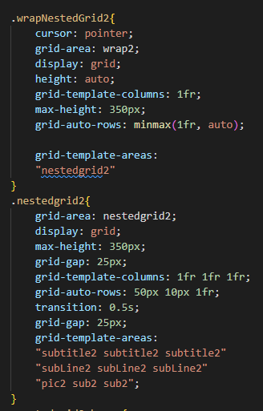

Contact Page:

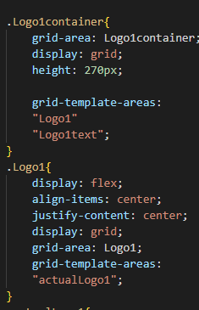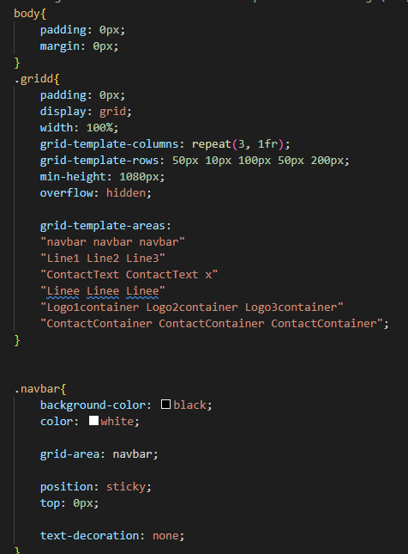

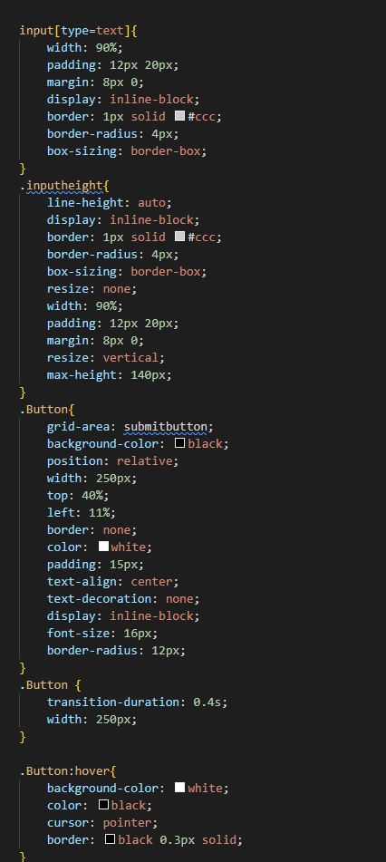

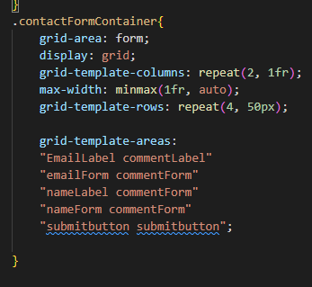

Banksy’s Story:

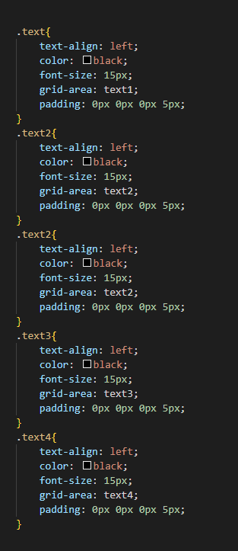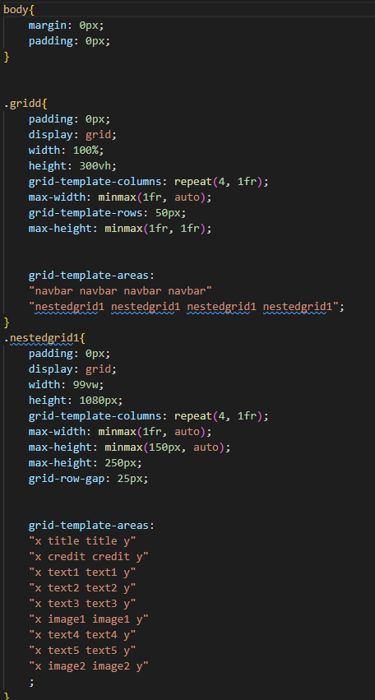

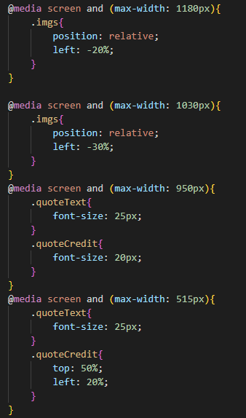Banksy’s Gallery:

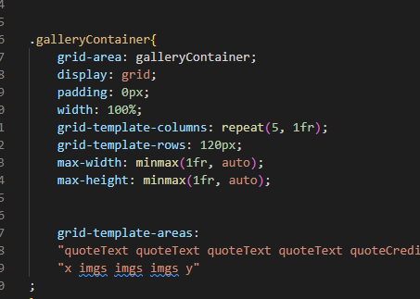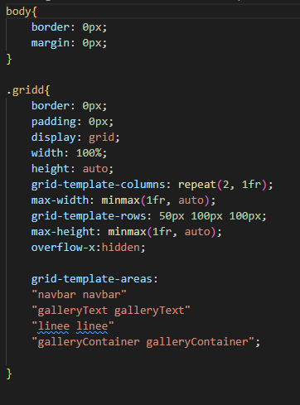

**Testing Section:**

|  |  |  |  |  |  |  |
| --- | --- | --- | --- | --- | --- | --- |
| **#** | **Test** | **Page** | **Input** | **Expected Result** | **Actual Result** | **Comment/Fixes** |
| 1 | Homepage button on navbar | All pages | Mouse 1 | Return to homepage | Returned to homepage | None |
| 2 | Contact button on navbar | All pages | Mouse 1 | Go to contact page | All pages went to the contact page | None |
| 3 | Hover effect | Homepage | Mouse cursor | Item hovered should scale by 1.1x | Went as expected | Transition could be made faster as the blurry during one can be disorienting |
| 4 | Clicking on story of Banksy container | Homepage | Mouse 1 | Should open relevant page | Went to said page | None |
| 5 | Clicking on Banksy’s gallery container | Homepage | Mouse 1 | Should open relevant page | Went to Banksy’s story page. | Onclick reference was incorrect |
| 6 | Clicking images | Banksy’s Gallery | Mouse 1 | Should open an enlarged image | Went as expected | Could add details or wording in each image when clicked |
| 7 | Hovering over images | Banksy’s Gallery | Mouse Cursor | Should scale the image by 1.1x | Went as expected | Transition could be a little bit faster  Could add box-shadow effect |

**Launch Testing:**

|  |  |  |  |  |
| --- | --- | --- | --- | --- |
| **#** | **Test** | **Yes** | **No** | **Possible Improvements/fix** |
| 1 | Are the webpages responsive |  | No | Homepage layout could be improved. The Gallery page is not responsive. |
| 2 | Did all navigation buttons work as intended | Yes |  |  |
| 3 | Minor spelling/errors | Yes |  | Spelling in contact page |
| 4 | Font sizing format, correct? | Yes |  |  |
| 5 | Is the website functionable in different screen sizes? | Yes |  | Layout for the homepage can be improved |
| 6 | Usability test | Yes |  | A navbar button for the ‘Gallery’ and ‘Banksy’s story’ would be more interactive |
| 7 | Browser compatibility | Yes |  | No changes between different browsers can be seen |
| 8 | SEOs have been implemented |  | No | SEO will be implemented after feedback |
| 9 | Works on mobile devices |  | No | @import could fix this |
| 10 | Webpages are responsive in different screen sizes and resolutions | Yes |  | Gallery page could be improved |

The transitions for all types (images and container) were sped up to smoothen the flow of my website. Especially on my container ones as the text can get disorienting and give a weird experience for the user as they get blurry for a while. Other than that, the website currently is functionable and is within at least satisfactory user’s need and website purpose.

Extra small details can be added later on. But for now, I’d first focus on improving the whole UX of my website. For that purpose, receiving feedback from other people would certainly be helpful in developing further on my website.

**Usability/Feedback:**

**Feedback #1**

|  |  |  |  |  |  |
| --- | --- | --- | --- | --- | --- |
| **#** | **Question** | **Agree** | **Neutral/Half-agree** | **Disagree** | **Comments** |
| 1 | Was the banner in the homepage relevant and appropriate? |  | Neutral |  | This design is certainly nice, however, the size might be too much, taking the whole screen seems inappropriate |
| 2 | Were the webpages responsive enough to function the same? |  | Neutral |  | The Gallery page needs improvement |
| 3 | Were the layout changes when resizing screen consistent with the theme? | Yes |  |  | Although Gallery can be improved upon |
| 4 | Was the navigation straightforward or simple? | Yes |  |  |  |
| 5 | Was my website educational? | Yes |  |  | The text could be improved by providing links to important references throughout the story |
| 6 | Do you think my website’s layout is simple enough for everyone to have an easy time navigating? | Yes |  |  |  |
| 7 | Do you think the theme and layout of the webpages consistent? | Yes |  |  |  |
| 8 | Was the whole experience overall appealing? |  | Neutral |  | It seems lacking in details or designs. The website seems so empty. |

**Feedback #2**

|  |  |  |  |  |  |
| --- | --- | --- | --- | --- | --- |
| 1 | Was the banner in the homepage relevant and appropriate? |  | Neutral |  | The banner is too large. Having multiple images in the banner would improve the website (slideshow) |
| 2 | Were the webpages responsive enough to function the same? |  | Neutral |  | The Gallery page needs improvement |
| 3 | Were the layout changes when resizing screen consistent with the theme? | Yes |  |  |  |
| 4 | Was the navigation straightforward or simple? | Yes |  |  |  |
| 5 | Was my website educational? | Yes |  |  |  |
| 6 | Do you think my website’s layout is simple enough for everyone to have an easy time navigating? | Yes |  |  | Adding a button for ‘Banksy’s gallery’ and ‘Banksy’s story’ would make it more interactive |
| 7 | Do you think the theme and layout of the webpages consistent? | Yes |  |  |  |
| 8 | Was the whole experience overall appealing? |  | Neutral |  | The design is appealing, but adding more details would be an improvement |

I later realised that the size of the banner was set in vw measurements, which means it scales with width of the screen size, and it being more than 100, the banner would result in taking the whole screen. To fix this, I have changed the measurement by pixel and made it smaller. Furthermore, the idea of having a slideshow in my banner sounded like a good idea. Although it can prove challenging, this is something that is definitely would be added later on. This way, it also adds details to an otherwise empty website, making it appealing for the UX.

Moving on, adding extra navigation to allow users to directly access the Gallery and Banksy’s story pages seems unnecessary. Since my website is already small and has very few navigation buttons, it would be too extra to add these features. Even if you’re not in the homepage, the user is 2 clicks away from accessing the aforementioned pages. Ultimately, trying to add this feature would waste precious time when instead you could allocate and dedicate more time in fixing bugs, adding more helpful features, or any other more that adds to the client requirements and website purpose.

Website Optimisation

**Homepage:**

**Before:**

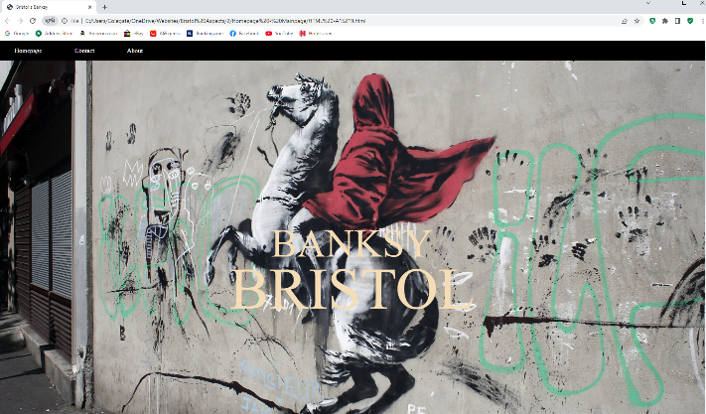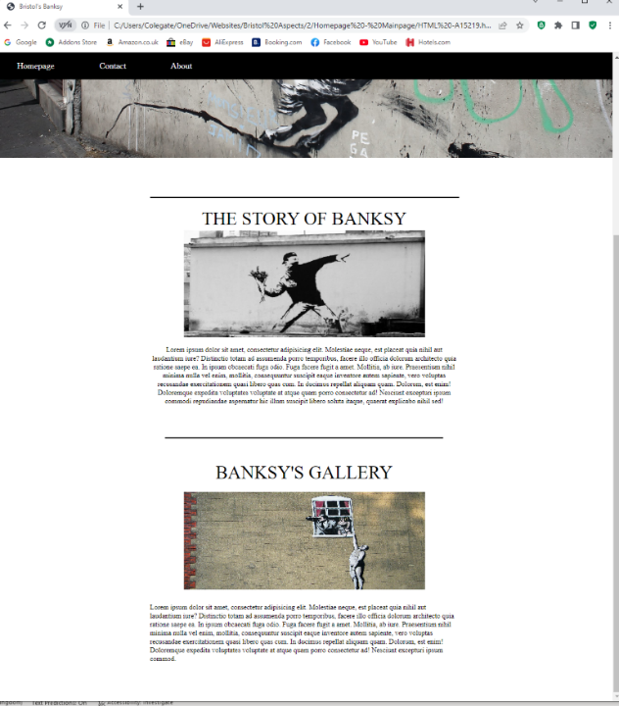

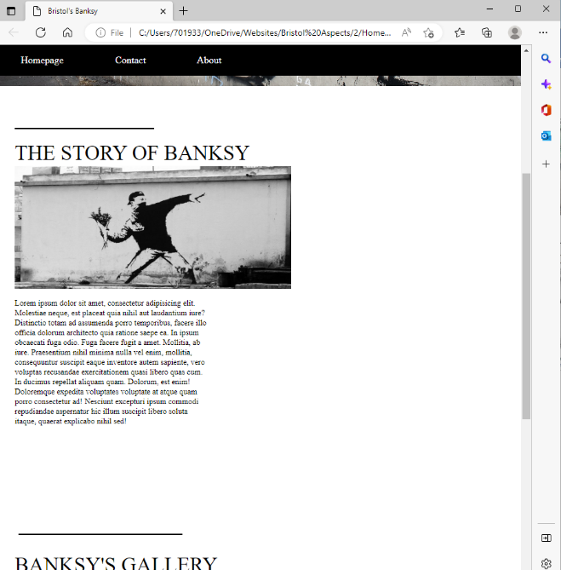**After:**

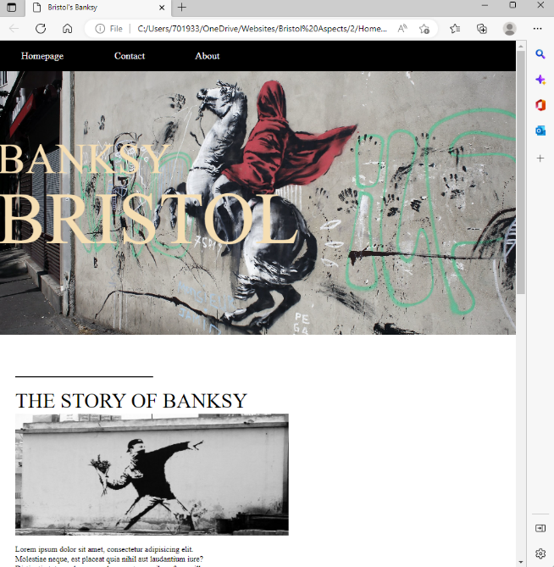

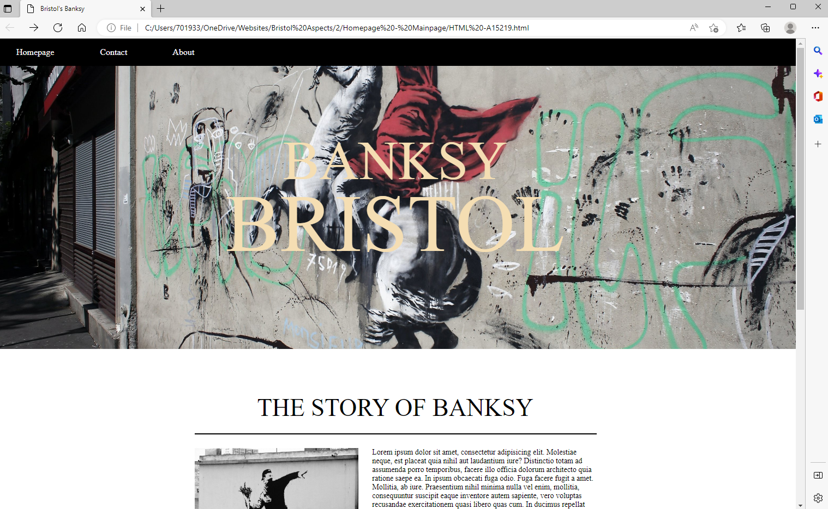

I decided to renew the layout when the homepage screen is resized. In this way, it remains consistent with other webpages since they have similar layout when responding with screen size. What I have changed was the position of the container for both the ‘Gallery’ and the ‘Banksy’s story’ page. I moved them to the left as it looks neater in my opinion. This also applied to the other layout changes in other webpages. The reason why it looks neater is because it complements well with the narrow width of the webpage screen. Due to this, it makes the while layout look more appealing and overall better in terms of simplicity.

Additionally, I also adjusted the banner image size to make it more appropriate for the user’s experience. This way, the website looks much simpler and not empty since objects and containers are closer together.

**About Page:**

I later decided to remove the about page for this website because it seems unnecessary and there are no details to be put anyway. With this change, I think the website looks neater and overall simpler.

Before:

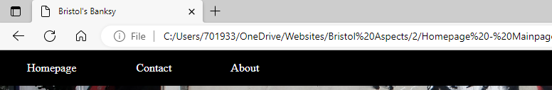

After:

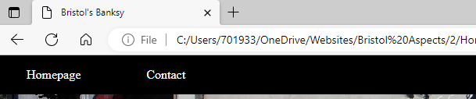

**Homepage 2**

Before:

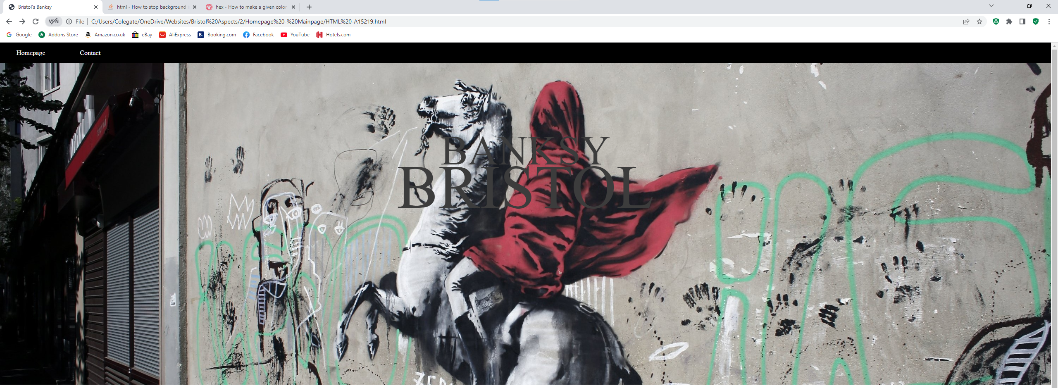

After:

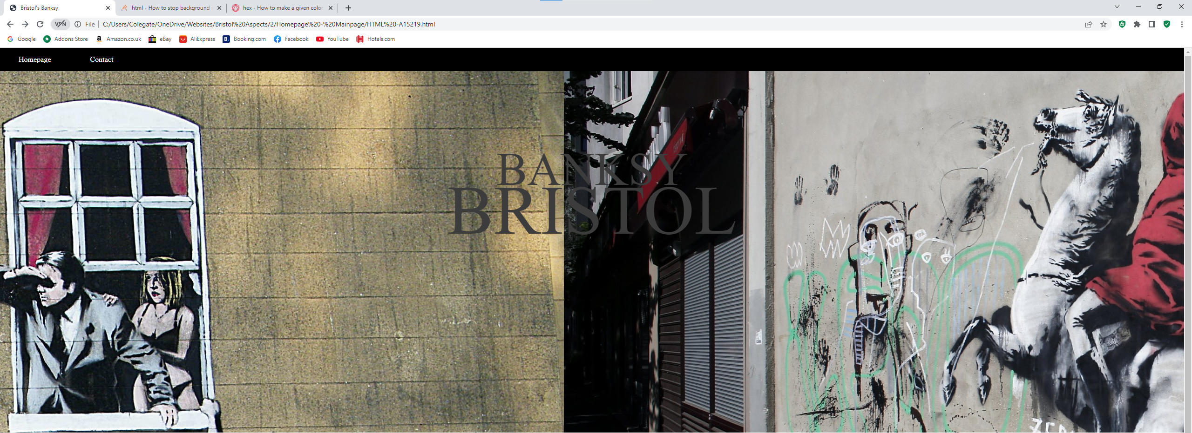

*It has a slideshow effect…*

For the homepage, to make it more appealing, I continued with the idea of making a slideshow effect on the banner. This effect complements really well with the mood and colour scheme that I picked. Moreover, this animation makes it more ‘alive’ and not make my website seem so empty.

This was done just with CSS using keyframes animation:

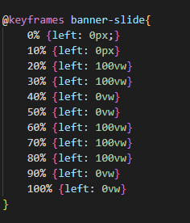

I also adjusted the colour of the title text to a lighter one: grey. This to prevent it from blending in with picture, making it more visible for the user.

**The story of Banksy Page:**

Before:



After:

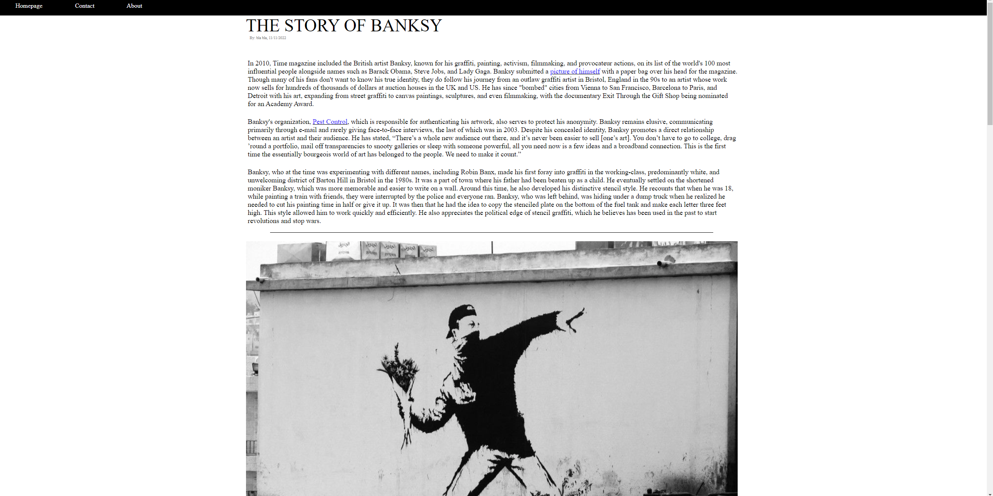

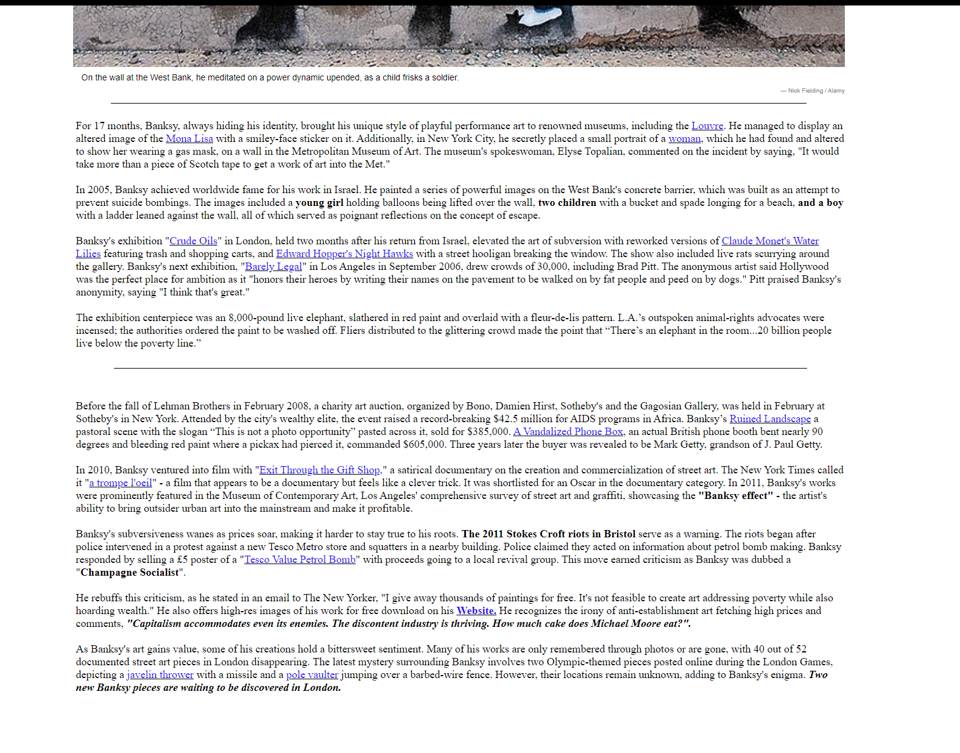

Since this is the highlight of my website, I put most of my effort in improving this page. As you can see from the Before and After, the text format doesn’t seem empty and lacklustre unlike before. Moreover, I was able to provide links for specific events and arts which provides further knowledge on this topic.

Furthermore, I also emphasised certain keywords (by italic and bold) to differentiate quotes and major events from normal text. This way, the webpage seems more interactive and looks like a legitimate article In my opinion.

Additionally, I also increased the font size of the text so that it is more readable from different screen sized and the user’s distance from the monitor, making it more convenient and friendly for the readers.

Since my story of Banksy is mostly simplified and not much deep details, adding links to the texts does not limit the user from learning more. This is also convenient for them as I assisted them which articles and/or websites are relevant to learn more from the story of Banksy.

Overall, from this feedback, the webpage seems to be more ‘alive’, informative, and convenient for the readers.

**Website Review**

Legal and Ethical considerations

In my website, I used images that came from other people (results from search bar). I don’t think I would have a copyright issue as they were all made public by the owners and were credited to them. Regarding, however, the article about Banksy’s story is concerning. Since I copied the format, the flow, and the idea of the write-up, it might be given a strike. But I already rewritten and rephrased most of the sentences, so hopefully there won’t be any serious issues when the website is uploaded (that is).

I don’t think there isn’t much to say about legal and ethical considerations; no object, item, nor any work was stolen and taken credit for.

Suitability

I believe that my website was able to satisfy and appeal its intended purpose, including the user and their UX. I was able to design, create, and improve on the client requirements through feedback, trial and error, and my insight. Overall, I have achieved what I have set to do; that is to educate and show people, whether or not they live in Bristol, about the works of Banksy and how he came to be.

In terms of dangerous or malicious content, there isn’t any. I don’t believe that I have included anything inappropriate regardless of age or gender. Because of this, my website can educate just about anyone who has access to it, making it more accessible to a very wide audience and users.

Strengths and Improvements:

One of the best trait of my finished website is its very simple and straightforward design. Because of this, users from any category would be able to navigate, experience, and learn from my website regardless of their technical skill. Due to this, the website is appeals to every kind of audience, which is already an advantage when looking for success in this business.

Testing Quality:

I believe through numerous tests and reviews from feedbacks allowed me to improve and do well in creating and optimising my website. The different kinds of tests that I put out certainly gave me insight from other people’s perspective which is a crucial factor when you make a website tailored for them (which all websites are). However, testing did not just provide me new ideas, it also showcased how well I did during the development of the website. As you may have noticed from the tests, there were little to no bugs that occurred; which is a good indicator of my skill. Although the website was fairly easy to make, it was still an impressive outcome considering this is my 2nd attempt in creating a website (in my opinion).

Overall, the test showcased flaws, skill, and possible improvements to make for my website.

**Evaluation:**

With that, the website is complete and final. Although it can still definitely be improved upon, the website has satisfied client requirement and needs in my opinion. Moreover, the website was also able to, during development, continuously improve in accuracy, simplicity, interactivity, and responsiveness. Throughout the process of making a website, I was able to spot potential issues through numerous testing and feedbacks. Because of this, the website continued to be improved on despite my lack in creativity and designing skills.

However, there are certain aspects during the development where I couldn’t come up any ideas to solve issues or problems presented. Most of the layout of my webpages were not very original since they were a mix of different websites that I came across. An example would be the Contact page; I copied it from Nike, however, since it suited very well with my theme and adhered to the client requirements (it being straightforward, simple, and easy to understand), I didn’t bother making changes on it as it seems already enough.

Other than that, during development phase, I made sure I kept the relevant files secured and such. I had multiple backups for them just in case and kept a copy in a drive with bit Locker. Although it might have been too much for a small project, it was a good idea to start and practice early and hammer it until it’s a habit; it’s a safe precaution and an essential skill in the future to have.